1. Problem statement:

Record a new session for base URL as https://magento.com/ and then click on the icon to navigate to

customer login page and then to Registration Page and automate all the fields.

2. code with comments:

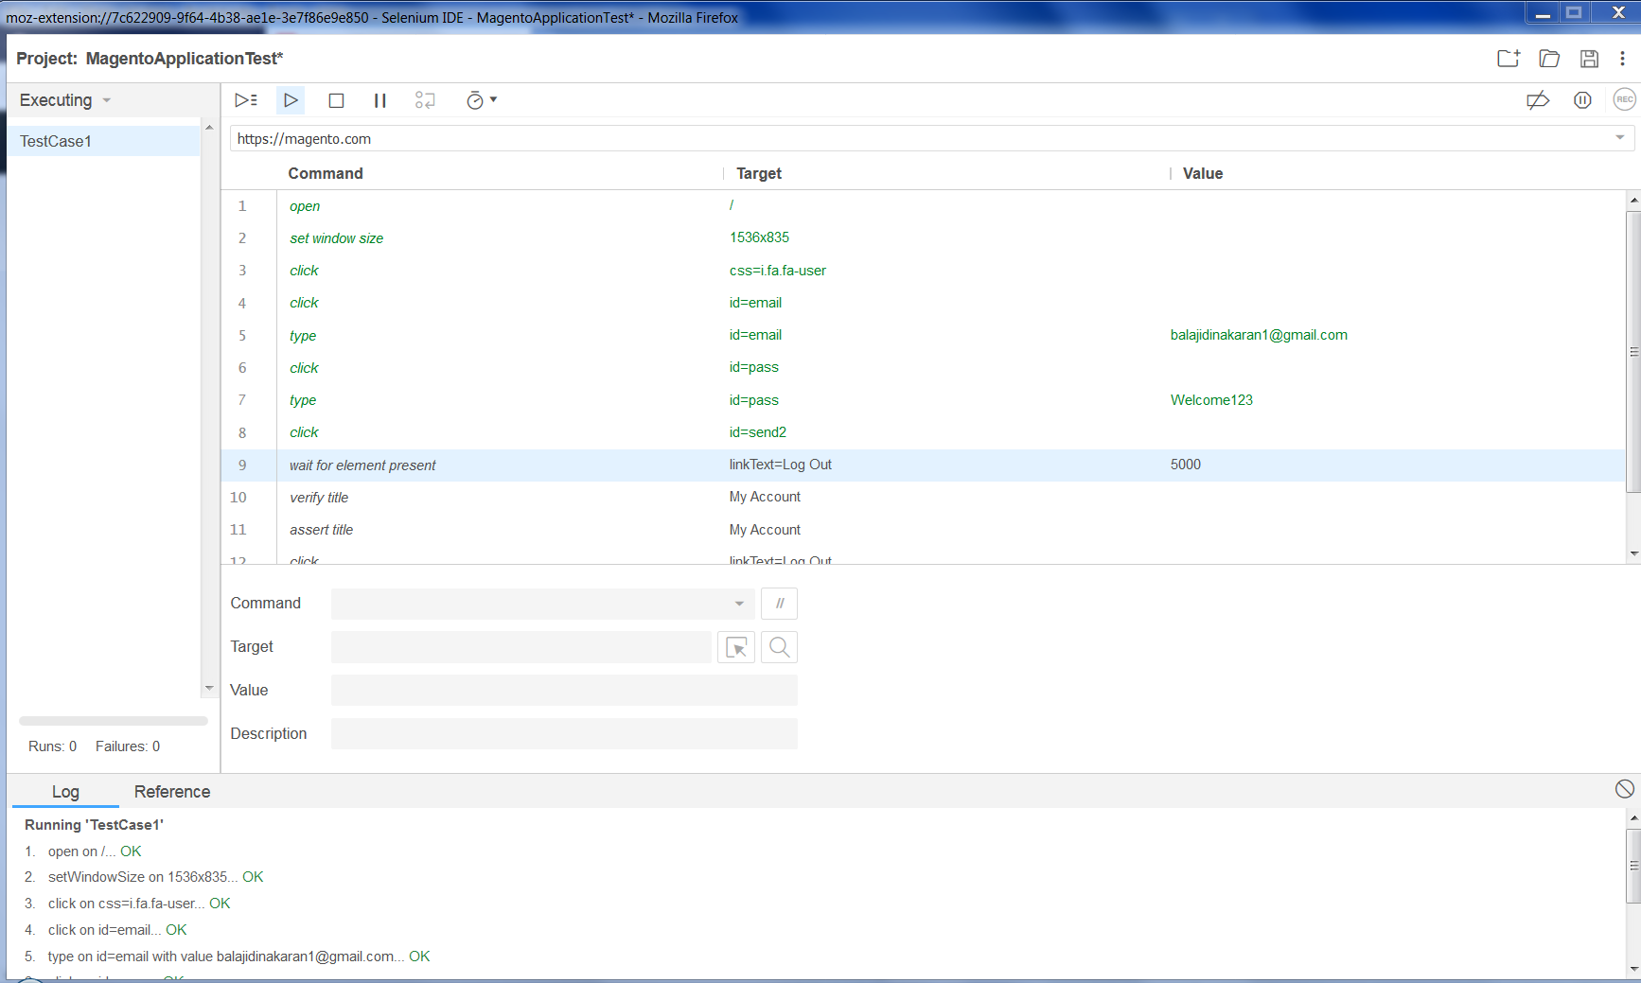

3. Explanation of the code:

Recorded a new session of magento.com using Selenium IDE as learnt in the session.

4. Result flow in detail:

Wait for element present is added step for the code to work properly.

5. Output screenshot:

